Software ISP operation introduction

(Ref: PBM-MN-015-EN)

Applied
TS248 | √
TS121 | √
TS3600 | √

Software ISP operation introduction
- New Version Boot loader supply four kinds ISP：
- Serial Port 2 ISP
- TCP/IP ISP
- U Diskette ISP
- USB With PC ISP
Note: frontal three kinds are in common use.
- Serial Port 2 ISP
- Connect the ECR and PC with COM ISP line.
- Open the ISP software on PC and Select the [Comport] as below picture:
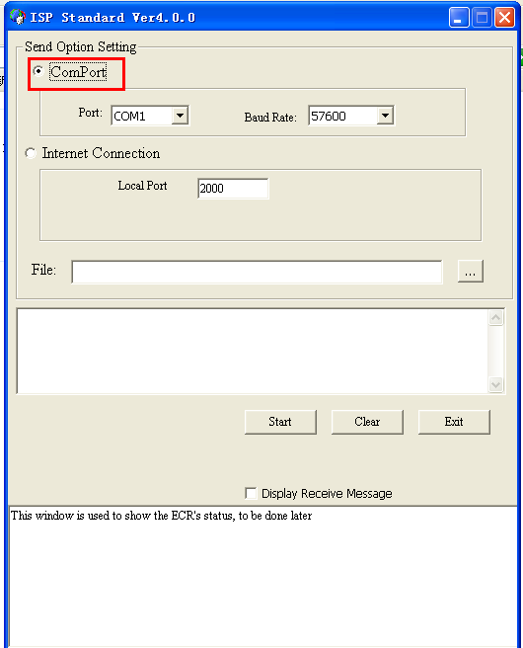
- Select Port：select the COM that ECR linked the PC from the down windows as below: 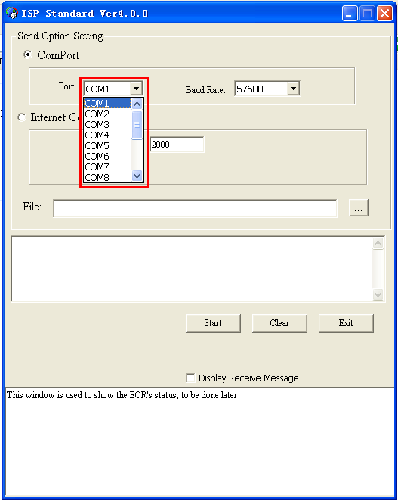
- Select Baud Rate: Select the baud rate of the ECR you need from the down windows as below:
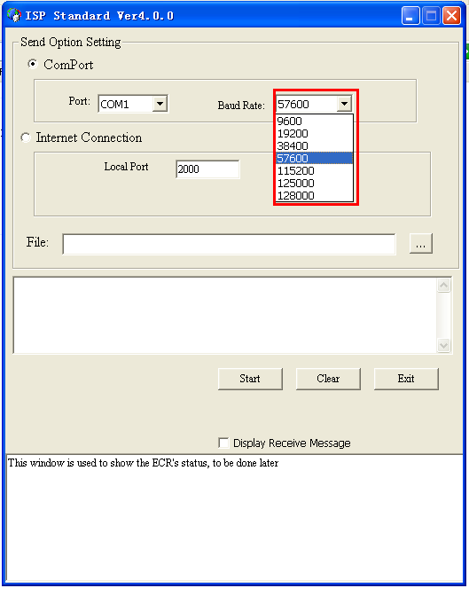
Note: The baud rate of the TS248/121/3600 is 115200.
- Turn MRG to the P mode on the ECR.
- In P mode, enter the interface by following step:
(410 – Options)→(System configuration)→
(System software)→(443—ISP update)→[enter]
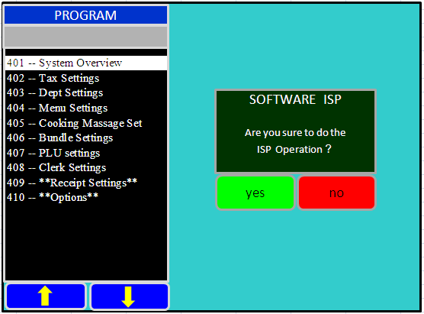
When you want to update the program, then select “yes”,or select “no”.
- After select “yes”, you will enter the ISP selections interface as below:
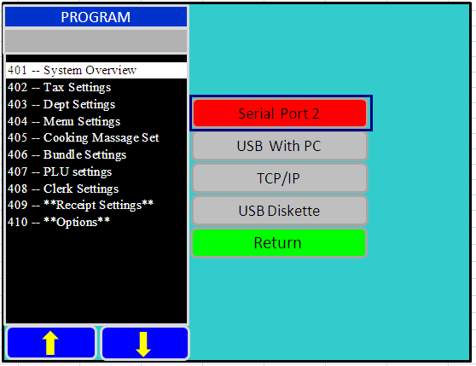
You must select “Serial Port 2”and Press [Next], and then the Serial Port 2 ISP is starting.
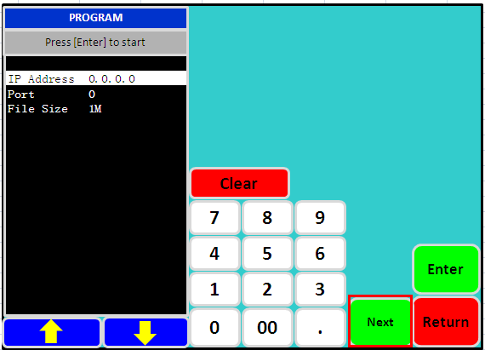
- TCP/IP ISP
- Connect the ECR and PC with the cable.
- Select the ISP software as below:
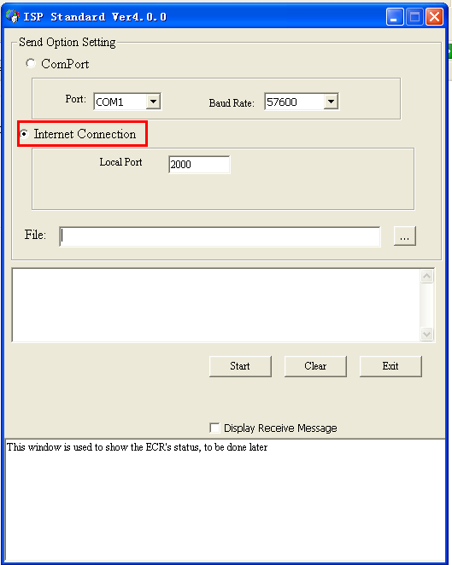
Note: the local port you can set what you need.

- Enter the ISP interface, select the TCP/IP.
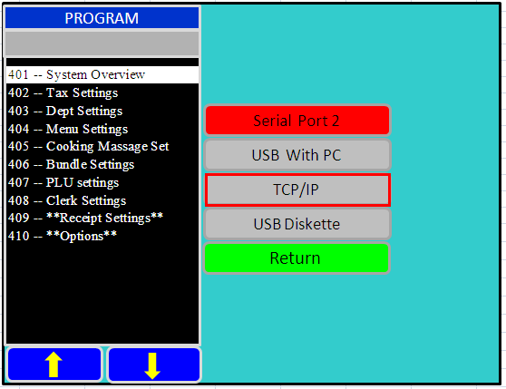
Input the PC’s IP Address and Port which setting on the ISP tool:
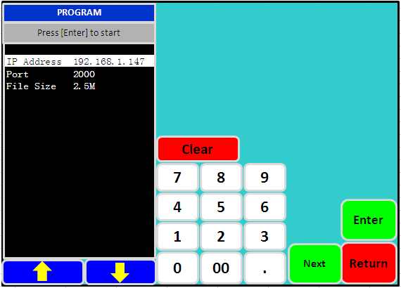
Then press [Next], the TCP/IP ISP is starting.
- USB Diskette ISP
- Insert the USB Diskette to the ECR’s USB port.
- Enter the ISP interface, select the TCP/IP.
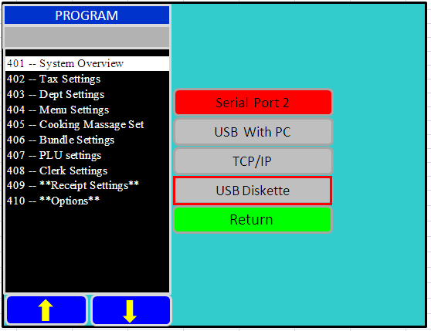
Select the USB Diskette, you will enter the ISP files selection interface, select the file ISP need and press [Enter], the USB Diskette ISP is starting.
- USB with PC ISP is same with serial port 2 ISP
- When finish the software ISP, the ECR will restart by itself.
- Do the initialization.
..Please refer the document ‘Master and Half Reset operation.pdf’.
- Compulsive SOFTWARE ISP
- The preset switch of TS248/121/3600 Compulsive ISP
SW1-1 | SW2-2 | ISP mode
ON | OFF | Serial Port2
OFF | ON | USB Diskette
OFF | OFF | Common run
ON | ON | USB Cable with PC
Note: USB Cable with PC Compulsive ISP, the Baud rate must be 57600
Serial Port 2 Compulsive ISP, the Baud rate must be 115200.
USB Diskette Compulsive ISP, the default file name must be ECR.bin
Compulsive mode, ISP file size is 2.5M
Compulsive mode, the ECR can’t restart itself.

